Experiment No: 06

Title: Implement program for Hierarchical and Hybrid Inheritance.
Roll No / URN No:2103 / 1024031087
Batch: S5
Problem Statement: Academic Management System using Hierarchical Inheritance in C++

Program:[C++ code]

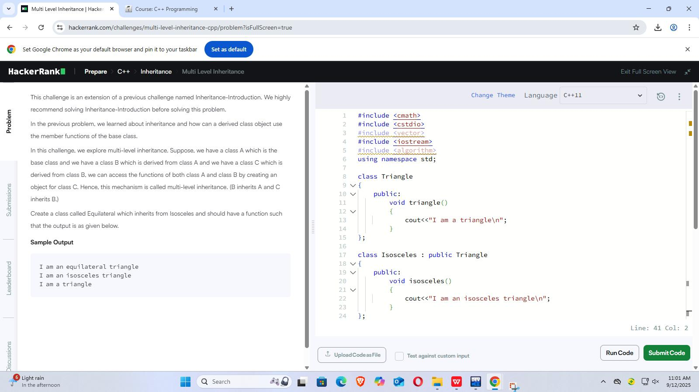

Output: [Input and Output]
